Lecture No.5 PARASITOLOGY DR.Raad H.H.
Phylum Nematoda
Order no. 1- Ascaridida
General character :
- General form Majority elongate worms
- Mouth shape With 3 lips
- Esophagus form Simple club
- Male reproductive system No cpoulatory bursa ;but have posterior bended end with papillae
- Egg shape with undivided zygote (embryo)
- Life cycle Direct
- Infective stage Swallow egg with L₂ (Ascaris) or Swallow egg with L₃ (Oxyuris)

"Family Ascaridae "
Genus Ascaris:
Ascaris lumbricoides
- It is called “ large intestinal round worm “. Could be lived 1- 2 years .
- Cause a disease called Ascariasis .
Morphology :
- Average female length 20 – 35 cm. ; male smaller 12 - 30 cm.
- Elongated cylindrical tapered anteriorly & posteriorly .
- It’s head provided by 3 fleshy lips.
- Female egg production daily about 200000 eggs .
- Egg spherical shape consist of 3 layers { a. 1st. thin lipid layer ; b. 2nd. Thick chitinous layer ; c. 3rd. thick proteinous layer } .

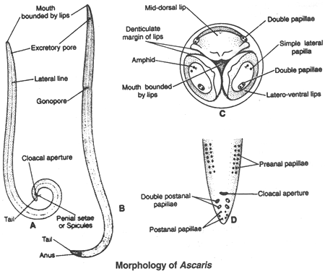

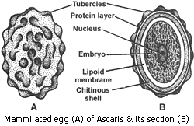

Symptoms in human ( it is depend on worm burden) :
- A number of worms 10 – 20, may go unnoticed except in routine stool exam.
- Vague abdominal pain is the commonest complain.
- Sever case's sings are listlessness , loss weight , anorexia , distended abdomen , intermittent loose stool , vomiting occasionally , fever , & worms may locate , block pancreatic ducts or billiary duct & forming calculi or hepatic abscess .
- Cough , wheezing , dyspnea , sub sterna pain ; these sings are observed during pulmonary stage & also the Infiltration of Esinophilia “Loffler’s syndrome “{ this syndrome is also observed due to Hook & Strongyloides worm infections }.
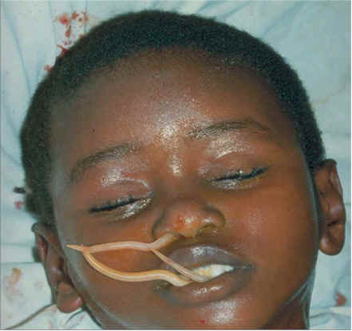

Ascaris summ
- Ascaris suum, also known as large roundworm of pigs
- Ascaris suum very similar to A.lumbricoides morphology
- Ascaris suum grows up to 40 cm in length
- Until recently it was believed that Ascaris suum could also infect humans;
- Ascaris suum could infects sheep but no reaching adult stage
- Ascaris suum is distributed worldwide
life cycle:
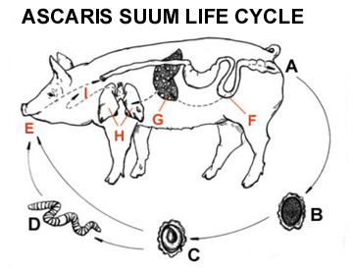

Ascaris suum larvae migrate from the small intestine (F) to the liver (G) via the hepatic portal vein and then to the lungs (H) via the heart. Knowing this, we can predict that important pathological changes will be found in the liver and lungs.
Symptoms of infection:
When juvenile worms are hatched, little damage is done by their penetration into the intestinal mucosa. Symptoms can be difficult to diagnose and confused with other diseases. Juveniles get into the respiratory system by breaking out of lung capillaries and causing small hemorrhages. Heavy infections cause small pools of blood to accumulate and causes edema. This, along with the accumulation of white blood cells and dead epithelium, causes congestion of the air pathways and is called Ascaris pneumonitis. With this condition the lung can become diseased and when bacterial infections become involved, it can lead to death.^{[3]}

Genus Parascaris
Parascaris equorum
Parascaris equorum are found worldwide, wherever horses and other equids are. (Von Brand, 1952)
When fully grown Parascaris equorum lives in the small intestines of the horse. (Monohan et al., 1995)
Parascaris equorum is large, cylindrical, and has a cuticle with three layers made of collagen and other compounds that protect the worm from the acids in the digestive tracts of animals.
The adult male ranges from 15-28 cm. The females are much larger and can grow up to 50 cm.
Parascaris equorum has three very large lips. Each of these lips has a transverse groove or labial sinus on the lateral margins, which divide the lip into apical and basal regions.
Adult females are able to produce nearly 170,000 eggs daily. They are able to produce up to 60,000,000 eggs annually.
The eggs of Parascaris equorum are almost spherical and have a brownish color. The eggs contain a 1-celled zygote and are between 90-100 microns in size.
Symptoms :
Parascaris equorum affects the young horses most often. It can cause verminous pneumonia ( may be hemorrhagic ) called summer colds , bronchial hemorrhage, colic, and intestinal disturbances ,sever enteritis constipaion followed by foul smell diarrehea. These symptoms can lead to sluggishness and morbidity. These roundworms may cause intestinal perforation or obstruction. The older horses commonly are immune to the infection. (Roberts and Janovy, 2000)

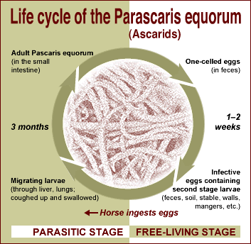

Genus Toxocara
Toxocara canis
- T. canis and T. cati are found worldwide in the soil. The eggs of these speciesoccur in 2-88% of soil samples collected in various countries and regions.
- Transmission and Life Cycle
The life stages of Toxocara spp. include:
• Unembryonated eggs excreted in the feces.
• Infectious embryonated eggs containing third stage larvae. This stage is present
after the eggs develop for at least 1 to 2 weeks in the environment.
• Immature larvae, which migrate through the tissues
• Dormant (‘hypobiotic’) immature larvae, found in various tissues
• Mature worms, found in the intestines
- The parasite at it’s larval stage only in the Human cause a disease called “Toxocariasis” & also cause “Visceral larva migrans”.
- It is a cosmopolitan Ascarid parasite of dogs .
- Human & rabbits is an accidental (Paratenic) host by ingestion of infective eggs came from lactating bitches or puppies.
- Human cannot produce or excrete eggs so it is not consider as a diagnostic sign.
- Genus Toxocara have anthers 9 species infects mammals .
Morphology :
- The male 4- 6 cm. ; female 6.5 – 10 cm. in length.
- The worm bearing lateral cervical alae ( Arrow head ).
- = = = = caudal = .
- The male bearing digit - form appendage .
- The eggs 85 x 75 um. Densely granular internally & it is pitted superficially .

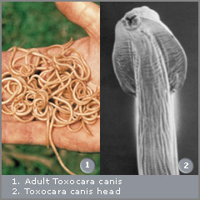
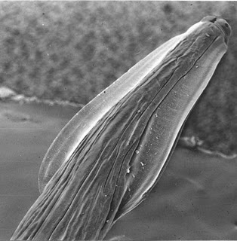

Cervical Alae: Modified lateral alae in the anterior region of Toxocara canis
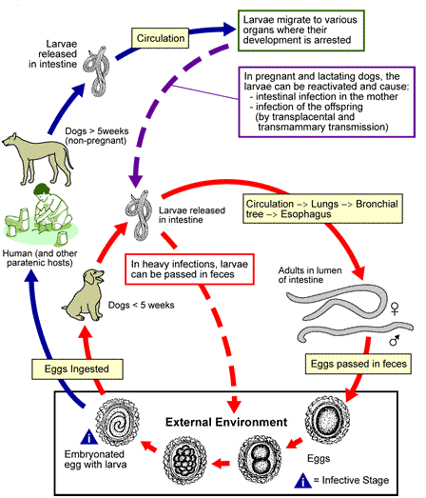
Life cycle of Toxocara canis :

Symptoms :
Young puppies usually have the most severe signs of toxocariasis. pot-belly”). Worms may be passed in the feces or vomited. Other possible symptoms are diarrhea, constipation, vomiting, flatulence, coughing or nasal discharge. Chronic enteritis can result in thickening of the intestinal walls or intussusception. In severe cases, puppies may die from obstruction of the gallbladder, bile duct or pancreatic duct, or rupture of the intestine and peritonitis. Intestinal infections with small numbers ;Pneumonia ;Symptomatic infections are rare in adult dogs. Most dogs with retinal lesions do not seem to be visually impaired.

Toxocara cati
- The Ascarid of cats .
- It causes intestinal infection in Human .
- It causes “Visceral larva migrans”.
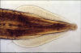
Cervical Alae: Modified lateral alae in the anterior region of Toxocara cati

Toxocara vitulorum
Male 25 cm. ; female 30 cm. with small transperant lips.
A remarkable fact about T. vitulorum is that the adult worms are encountered principally in suckling calves. The dam sheds no T. vitulorum eggs even though she is the source of infection to the calves. This is because the larvae in the cow do not develop to adults but remain in third stage. When the cow is pregnant the larvae migrate from the liver to the mammary gland, and prior to parturition, to the milk through which the calf is infected (Roberts, 1990c, 1993).
Toxocara vitulorum is among the most destructive parasites of young ruminants. The larvae of T. vitulorum undergo migration that inflicts great damage to many organs, especially the liver and the intestine. It responsible for 11 to 50% mortality in calves of cattle and buffalo (Srivastava and Sharma, 1981; Makundi et al., 1996).

It can infect many species such as carabao but the main hosts are cattle and buffalo in tropical and subtropical countries. Experimentally it can infect rabbits and mice (Gupta and Ramaswamy, 1985; Omar and Barriga, 1991; Barriga and Omar, 1992)

Toxascaris leonine

It has characteristic shape of simple lateral appendage in the tail.
The adult worms are usually 3-4 inches long and can be seen in the feces and vomit of the animal.
Toxascaris leonina differs from other Toxocara in that the larvae do not migrate through the lungs; but rather, the entire developmental cycle occurs in the gut.
Toxascaris leonina is a common parasitic roundworm found in dogs, cats, foxes intestinal lumen, and related host species. Toxascaris leonina, or T. leonina, is an ascarid nematode, a worldwide distributed helminth parasite which is in a division of eukaryotic parasites .The definitive hosts of T. leonina include canids (dogs, foxes, etc) and felines (cats), while the intermediate hosts are usually rodents, such as mice or rats (paratenic host). Infection occurs in the definitive host when the animal eats an infected rodent. While T. leonina can occur in either dogs or cats, it is far more frequent in cats.

Pathogenesis & P.M. of Ascaridae :
- Pathological changes accompanied larval migration which includes hepatitis ; verminous pneumonia ; esinophilic bronchitis ;pulmonary emphysematous ; esinophilic infiltration & nodules which it is circumscribed white to gray nodules (eosinophil-ic granulomas) have been found in the liver, lungs, kidneys, heart (epicardium and myocardium), spleen, diaphragm, intestinal serosa and other tissues.
secondary bacterial infection.
- Pathological changes accompanied adult stages which includes esinophilic catarrhal enteritis ;intestinal obstruction ;vomiting ;obstructive jaundice ;debility.
- P.M. includes above Pathological changes & presence of Milky spots due to larval migration plus presence of carcass special Ether odor & presence of adults worms in intestine .
Visceral larval migrans
The Visceral larval migrans type recorded in 1952 ; It is defined as the invading of larvae of species that are naturally adapted to hosts other than Human & they remain for periods in the tissues e.g. Liver & Brain & other numerous organs including Eyes ( Retino – blastoma ) . The frequently charged & diagnosed are of Toxocara and mostly T. canis .
The clinical picture varies from asymptomatic to a syndrome of chronic Hyper Esinophilia , Hepatomegaly , moderate pulmonary infiltrations , fever , cough & hyperglobinemia .
This phenomena noticed frequently in children ( up to 4 years ) due to contact with dogs & gain infection through swallowing infected eggs .
Prevention could be done by using sanitary measures & routine examination of Pets & cleaning animals & it’s places ; in addition to using Anthelmintics especially in pregnant bitches .
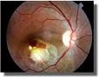
Diagnosis :
- Histopathological exam. Of tissue biopsy.
- Ophthalmoscope exam. For eyes .

Treatment in human :
- Mebendazole 100 mg./ kg. / b. i. d. / 3 days .
- Thibendazole 25 mg. / kg. /b. i. d. / 5 days .
- Prednisone for allergic symptoms ; 20 – 40 mg. daily reduced after 3 – 5 days .

Ascaridae Diagnosis :
- Symptoms .
- Stool exam . for identification of eggs ; egg count / gm.
- fecal flotation exam
Ascaridae Treatment :
"de-wormers", and includes such drugs as ivermectin ;fenbendazole, oxibendazole ; pyrantel pamoate , milbemycin oxime, and piperazine.
Ascaridae Control & prevention :
- To prevent reinfection of parasitic roundworms, it is recommended that anything that the animal has been in contact with should be cleaned thoroughly or replaced, including bedding and kennels. It is also strongly recommended that outside areas where defecation may occur be cleaned, as well as all feces removed daily from outdoor pet runs, crates, and the yard.
- Home & community sanitation .
- Proper food cooking .
- Eggs in feces could be destroyed by composting with increasing soil temp. without affecting the fertilizing action of the matter .

Note :
There are some rarely zoonotic Ascarid worms species that infect Man such as :
- Lagochilascaris minor :
Which causes subcutaneous nodule lesion in the Neck that contains the worm.
Recorded in south America .
- Anisakis simplex :
Which causes Esinophilic Granuloma or abscess in the stomach of European or Japanese Human due to eating raw marine fish containing larvae .

